ISRC Technical Briefing

The Future of Business Intelligence

Henry Yan
PhD Student
C.T. Bauer School of Business
University of Houston
Hyan3@uh.edu
The Future of Business Intelligence

Abstract: This paper examines limitations in using current business intelligence systems, analyzes the causes of these limitations and describes how future BI systems will likely address them. An ever more dynamic competitive environment will require future business intelligent systems to be real-time/near real-time, proactive and pervasive.

Business Intelligence Defined and its Limitation

Business Intelligence (“BI”) refers to a broad category of applications and technologies for gathering, providing access to, and analyzing data for the purpose of helping enterprise users make better business decisions ^{[1]}. It includes the extraction-transformation-loading (“ETL”) process, data warehousing (DW), online analytical processing (“OLAP”), data mining, and querying techniques, etc., as shown below ^{[2]}. Recently there has been great interest in BI, explained by users’ desires to gain competitive advantage and vendors’ interests in helping them do so. It is reported that the BI market has reached $5.73 billion in 2006 and it is still growing by more than 10% annually ^{[3].}
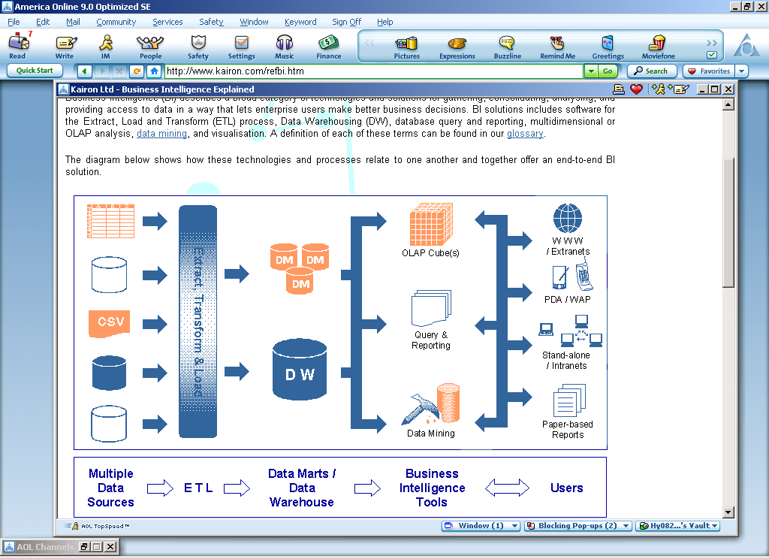
Yet current BI tend to be a reactive, esoteric process based primarily on historical data.

BI relies on a data repository (e.g., data warehouse, data marts) containing historic data typically derived, but separate, from an organization’s transaction processing systems. This ensures that long and complex analytical reporting queries do not interfere with transaction processing systems. Further, some time-consuming queries can be pre-stored to speed up queries and flatten out computation demand. In large organizations, the processes of ETL and querying can be remarkably time-consuming, cumbersome and, occasionally, even error-prone.

BI based on such historic repositories is inevitably reactive. Reports are assembled by analysts based on requests from viewers, either of whom can neglect important changes in the business environment that may not be reflected in the historic data. Analysis based on this type of BI can summarize and evaluate how the business has performed so far, but fails to support proactive mechanisms to help business decision-makers formulate strategy to cope with current and future events.

Business intelligence tends to be an esoteric function because it is an entangled process that calls for employees with specialized knowledge and skill both in business and technology, a combination in short supply in most organizations. Analysts must understand what viewers are interested in and how business is run, but they must also have the technical skills to formulate complex queries, design intuitive reports, optimize retrieval, and so on. Such a small group of BI specialists can evolve into isolated elitism, a bottleneck in maximizing the functionalities of BI.

The historic, reactive and esoteric natures of current BI systems are increasingly incompatible with today’s highly competitive and fast-paced business environment and business community that increasingly calls for real-time/near-real-time ^{[4]}, proactive and pervasive ^{[5]} BI systems.

Tomorrow’s BI will be real-time or near real-time

Alliant Energy Corp. recently reported that their new BI system has drastically reduced the time required to prepare their financial reports from 3 days to just an hour and this faster access to their financial information enabled them to quickly spot a short change of $50,000 before it had a significant financial impact on them ^{[6]}. Numerous other incidents have also shown that BI systems should provide real-time or, at least more current, information. A survey on 540 organizations by Gartner ^{[7]} illustrates a sharp increase in reliance on both real-time and day-old information. .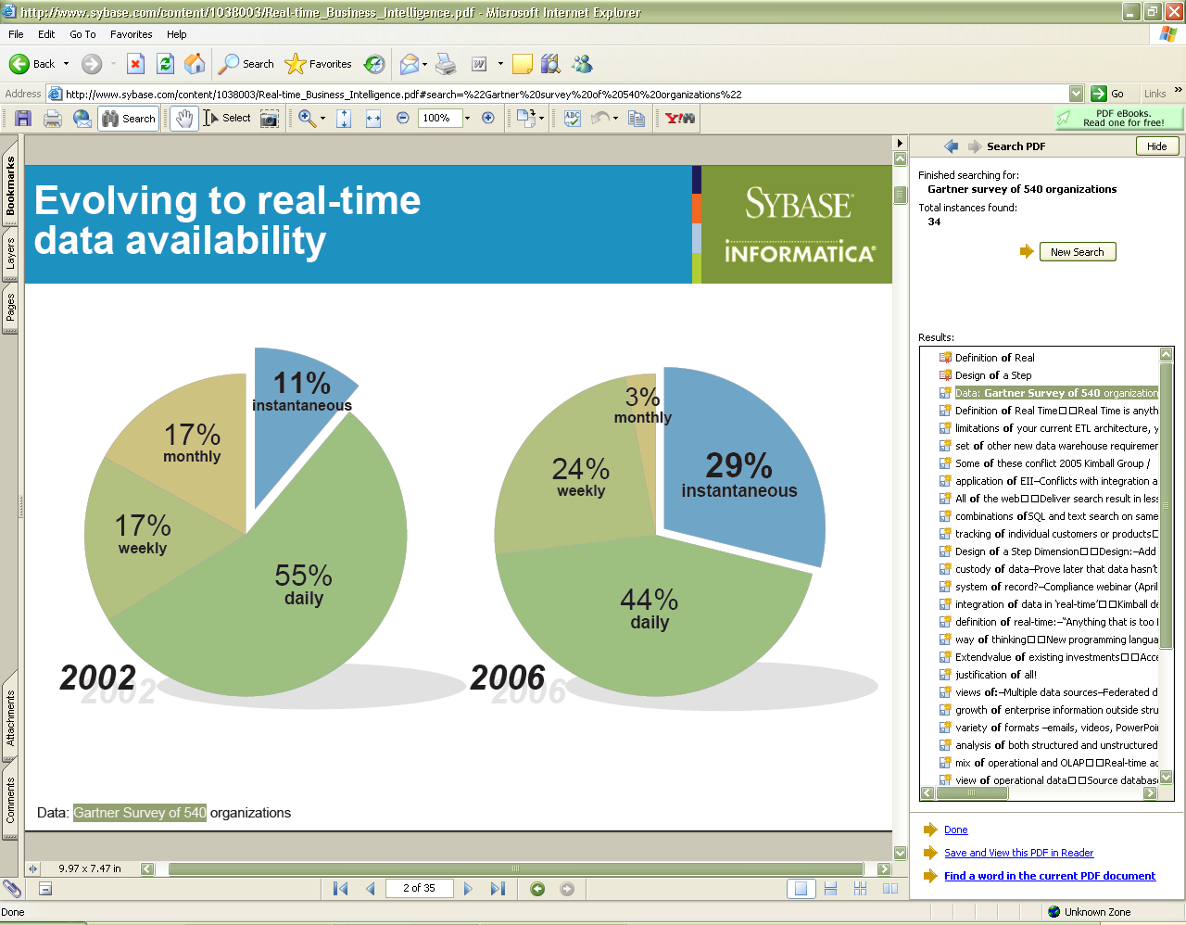
Thus, we predict that real-time or near real-time BI systems will be the future standard. One potential solution is to bypass the data warehouse ^{[8]} for time-sensitive analyses so that BI systems can access the live transaction data ^{[9]}. Doing so brings BI steps closer to real-time/near real-time capability, while eliminating errors often inherent in the lengthy ETL process. One downside, however, is potential underutilization of the current technology that has cost millions of dollars to deploy.

There are other solutions that attempt to improve the performance of BI by decreasing lags between the live and historic data repositories or providing faster access to BI. Progress can be made on both dimensions by adopting parallel processors and 64-bit in-memory processing technology; these have the potential to improve BI performance by factors of 10 to 100^{[10]}, Another option for improving performance is grid computing ^{[11]}, as already demonstrated by the National Institute of Environmental Health Sciences (NIEHS). The data volume analyzed by NIEHS researchers exceeds several terabytes and they have scaled SAS data mining software across dozens of different servers, allowing multiple SAS instances to run in parallel. According to Roy Reter, IT security officer and system administrator at NIEHS, this “has helped us to reduce by up to 95% in some cases the execution time required for these key projects” ^{[12]}.

Tomorrow’s BI will be proactive

A band of chiropractors, with the help of insured “patients”, recently bilked insurance companies out of millions. The independent Blue Cross Blue Shield provider Highmark Inc. was one of the victims. Analysts in the company succeeded in detecting these fraudulent practices through their homegrown BI system that provided reports to help identify suspicious treatments and billing patterns, but a more proactive system with more embedded intelligence could have enabled them to detect insurance abuse earlier and easier ^{[13]}.

Current BI systems work under directions from human beings. As business operations become more complex and bigger in scope, even the brightest analysts working with due diligence and utmost professionalism may, and probably will, neglect subtle changes in data due to changes in business operations or environment. This is compounded by situations where analysts make mistakes in their judgments, intentionally “goof” in their work due to grievances, or fail to perform up to par because of incompetence or other human frailties. All these can cost businesses tremendous amount of money. Such failures, or at least some of them, can be detected and signaled to analysts and management if BI is proactive with embedded artificial intelligence.

To illustrate the importance of BI being proactive through artificial intelligence, let’s draw an analogy between BI and the traditional database management systems (DBMS). Currently most main-steam DBMS vendors have already equipped their products with certain levels of intelligence, as manifested in their capabilities of not only dynamically notifying database administrators (DBAs) of performance issues (e.g., processor constraint, insufficient memory) via emails, beepers or cell phone calls. These systems increasingly push critical information to DBAs, thus lessening downtime and therefore the impact upon business; they can also automatically reconfigure allocation of resources such as processor and memory to cater for different levels of loads, a proactive approach to ensure constant availability. Should not BI systems be able to provide similar guidance and capabilities?

Likewise, in the world of the Internet, intelligent agents are used to track users’ web behavior, enhance their browsing and shopping experience and ultimately boost online sales. Could similar concepts be introduced into BI so that it can track and “learn” analysts’ pattern of interests and then proactively provide alerts when something goes wrong or an opportunity presents itself?

Granted that those technical parameters in DBMS might be more well-defined or less entangled with other factors than some business parameters such as gross margins, ROI or customer satisfaction index, but should BI systems be capable of achieving similar capabilities, then they could begin to bring us the following opportunities and benefits.

The

push of critical information to analysts and management, coupled with automated problem escalation along organizational chains will alert analysts and executives to changes in operations or environments, thus mitigating negative impacts due to human negligence or incompetence.

The proposed automatic reconfiguration feature in BI may lead to a system in which critical financial or marketing objectives such as gross margin, ROI or customer satisfaction index can be established during the budgeting phase so that any event leading to deviations of these targets can be detected and corrected by dynamically reconfiguring such things as sales price, inventories or promotions so that financial or sales mishaps can be prevented.

Finally the machine learning through intelligent agents in BI will liberate analysts from repetitive works and enable them to focus on more critical or strategic issues.

Such capabilities in BI systems call for extensive application of artificial intelligence and changes in the architecture, design methodology and implementation strategy of BI systems.

Tomorrow’s BI systems will be pervasive

Eastern Mountain Sports Inc., an outdoor specialty retailer headquartered in Peterborough, N.H., has reported a 73% increase of sales on footwear accessories, thanks to its BI system that gives a common view to almost everyone in the company from CEO to the store managers who can in turn identify locally successful sales tactics and formulate company-wide operation strategy ^{[14]}. A pervasive BI system is conducive to competitive advantage. Pervasiveness means ubiquity, which in turn mandates that BI user interfaces be inexpensive and user-friendly to make widespread and cost-effective adoption by users of varying sophistications possible.

Ubiquity can be achieved by mobile device and large-scale deployment in traditional computing environments that enable users to access BI wherever and whenever they wish, although such ubiquity will arouse security concerns that are less worrisome in a more closed environment.

For cost-effectiveness and user-friendliness, BI user interface may be piggyback on web browsers or office productivity software that are already widely adopted for existing purposes (a sunk cost!) and familiar to most business users. This will not only reduce maintenance and licensing cost but also help flatten learning curves. It is already widely predicted that Microsoft may incorporate some of BI capabilities into their next generation of office software, Office 12. Service-oriented architecture ^{[15]} and open-source architectures will also help reduce the total ownership cost of a BI system. Open source BI vendors such as JasperSoft and Pentaho are already advertising promising products, although they still have to prove their products can compete against commercial counterparts in terms of capability and after-sales support.

Conclusion

Business intelligence play an increasingly critical role in tomorrow’s ever faster, ever more global, every more competitive business environment. To meet those needs, future BI systems must be real-time/near-real-time, proactive and pervasive. Users are increasingly demanding those capabilities and software vendors have begun to respond. We see a bright future emerging for business intelligence.

References

[1] Wikipedia, http://en.wikipedia.org/wiki/Business_intelligence
[2] http://www.kairon.com
[3] Snapshots: BI Bounce, Setempter 18, 2006, p.54, ComputerWorld.
[4] The Future of Business Intelligence and Its Role Within Business Performance Management, a white paper from Hyperion Solution, 03.31.04.
[5] The Future of Business Intelligence from Hyperpion, Vijay Lal, 2005.
[6] Viewing Fine Details in Financial Data, ComputerWorld, Vol. 40, September 18, 2006.
[7] Real-time Business Intelligence, Evoluation in Information Access, Web Seminar Series, 2005, Sybase, Inc.
[8] Christopher Lenzo, director of Macola Products and Operations, Exact Software North America, Andover, Mass.
[9] Business Intelligence 2006 – Only the Beginning! Wayne Eckerson, Director of Research and Services, May 2006, TDWI.
[10] Lothar Schubert, director of SAP NetWeaver product marketing, Walldorf, Germany.
[11] Clive Longbottom, Head of Research, Quocirca. IT Analysis Communication Ltd.
[12] Grid Computing Accelerates BI Analytics, Stephen Swoyer, Athens, GA.
[13] Detecting a Web of Fraud, p.36, ComputerWorld, September 18, 2006.
[14] Getting Smarter with Each Sale, p. 45, ComputerWorld, September 18, 2006.
[15] Business Intelligence Web Service white paper, 2003, Business Objects Corp.

